Czech-Austrian Winter and Summer School

Reliability of energy
relevant strategic plans
in Austria and the Czech Republic

Co-operating Universities



Financial support by

Prague and Vienna, 2010

Content
Content 2
1. Introduction and General information 3
2. Abstract 3
3. Motivation 3
4. Paper 4
A brief history of energy in politics in Austria: Hydro and nuclear power generation 4
Relevant plans related to energy in Austria since 1990 till 2005 5
Current Situation in Austria 7
Implications 7
Summary 8
References 9

1. Introduction and General information

2. Abstract
Strategic plans are a very important political tool for setting a long term energy policy. Only such allows investors to predict the energy market adequately. Without these plans the competitiveness of renewable resources (RES) would be in question. Long term planning also helps improving the effectiveness of the energy scheme. Although many European countries have these documents, the question still remains if these predictions were met. This paper tries to outline the reliability of such plans, issued by the governments of the Czech Republic and Austria.

In a first step, this paper lists energy relevant strategic plans of both countries, which were set up in the years between 1990 to 2005 and their various goals. In a next step these goals are compared with the effective improvements, for example the share of renewable resources. For this, current data from statistical offices and official agencies are used. These two different sources of data then should be compared according to their conformity. Due to the observed findings we get from this analysis, a judgment about the effectiveness of strategic plans in reaching the predictions will be done.

In the end of our paper we discuss the reliability of the plans, especially out of an investor’s view. For the possible differences, we will try to discuss political, social and/or economical reasons briefly.

3. Motivation
The EU wants to be the global promoter for environmental responsiveness. Therefore, tight schedules and time tables for reaching various environmental goals (for example reducing CO₂ emissions via various policies, enlarging the share of renewable resources in energy production or supporting “green” technologies) exist and the Union pushes its Member States to comply with them.

However, these aims often are too ambitious and cannot be reached by the States. The case of Austria and its Kyoto targets are shown in Figure 1. By the Kyoto Protocol, the EU 15 Member States are required to reduce its CO₂-eq. (equivalents) emissions by 8 % below the basis year 1990. As the figure shows, the EU 15 will outreach this aim, in reducing 13 % overall – though there is one Member State breaking the rank: Austria. As the only country among the EU 15, according to its own valuation, Austria will not reach its aim to reduce its CO2-eq. to 13 % below 1990. It has to be noted, that all of these figures are submitted by each Member State to the European Environment Agency and are based on their self-assessment.

Nonetheless, the case of Austria shows, that, especially environmental goals need a critical evaluation. As this topic is very complex and the field of research quite young, a feasible assessment of a State‘s potential in complying with goals, is difficult.

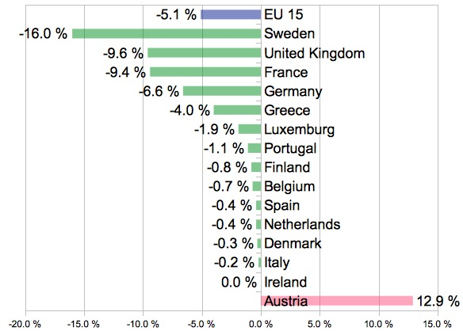
Figure 1: gap between CO₂ eq. emissions and Kyoto targets of 2008 – 2012
(data from EEA, 2009)

4. Paper

A brief history of energy in politics in Austria: Hydro and nuclear power generation
As great parts of Austria lie in mountainous regions, hydro power has always been a major energy resource. In 1947 the construction of the reservoir power station Reißeck-Kreuzeck began, which was completed in 1961. Together with the in 1955 completed reservoir power station Kaprun, these two projects marked the first milestone for several hydro power projects. Hydro power stations along the Danube and other major rivers followed. (cf. Veichtlbauer, 2007) These projects were very important for the re-construction and electrification especially after World War II. However, several projects had to be abandoned because of resistance from local residents like the Krimml Falls or the Umbal Falls while other projects, like the Wauchau dam on the Danube, were pushed through. (cf. Neuwirth, 2008)

In 1953 the “Atoms for Peace” program proposed by U.S president Eisenhower promised a safe, clean and cheap source of energy. Despite all risks and concerns regarding nuclear power, there are three advantages which could not be questioned by skeptics: the small space nuclear fuel saves compared to fossil fuel, the fact that a nuclear power plant has to be recharged only once a year, which results in reliability, and the fact that a nuclear power plants does not emit CO2, NOX or SOX during its operation and therefore it is no contributor to acid rain and climate change. This is the reason, why Austria’s population was at first totally fond of the concept of nuclear power generation and in 1971 the construction of Austria’s first power plant at Zwentendorf was under way. During the 70s, campaigns of opponents of nuclear power started to mobilize the population against this first plant. The construction was completed by 1978 and by that time the opposition gained lots of influence and put political pressure on the governing Social Democrat Party under the chancellor Bruno Kreisky. He decided then to hold post-war Austria’s first referendum about launching Zwentendorf. To his and everybody’s surprise, the referendum turned to a No with 50.5 % of the votes. Because of this narrow poll, the nuclear supporters hoped for a second referendum till six years later, after the disaster at Chernobyl, they gave up. Today a ban on nuclear power generation is written into the Austrian constitution. (cf. Neuwirth, 2008)

Relevant plans related to energy in Austria since 1990 till 2005
Though the European Union issued a white paper about energy in November 1997 (cf. European Commission, 1997), the ratification of the Kyoto Protocol on 31 May 2002 was an indirect first commitment to an energy strategy. To reduce the greenhouse gas emissions of 13 % between the years 2008 and 2012, Austria had to rethink its use of energy in the industrial production, transportation, agriculture and waste management. (cf. BMLFUW, 2002b) In June the same year, the Minister for Agriculture, Forestry, Environmentand Water Management, at then Wilhelm Molterer, presented a strategy in reaching the Kyoto goals. In the so called “Kyoto Action-package”, several sectors are listed, where measures for reducing CO₂-eq. on a federal and state level are suggested and how they were funded.
For example in the sector space heating, thermal-energetic renovations of old houses could lead to an annual reduction of 1.6 Mio t CO₂-eq. Old houses are buildings erected between 1945 and 1980 as here the greatest potential for cost efficient renovation are seen. Furthermore the strategy suggested, that there should be a focus on renewable energy sources if the heating system is changed, or a new building is erected.
The strategy paper also addresses the topic of how to save energy. In private and service sector, the consumption of energy should be reduced to an annual increase of 0.5 %. This would save 0.8 Mio t of CO₂-eq. Energy production should have its focus on new investments of water power and the intensification of renewable resources. Furthermore, distant heating which uses the waste heat, and efficiency improvements in petroleum processing should also lead to a reduction of emissions. In total 2.1 Mio t CO₂-eq. should be saved. Actions set in the waste management could reduce 1.1 Mio t CO₂-eq. till 2010. Due to the new landfill order (Deponieverordnung), waste can only be landfilled, if it had been burned ensuring a maximum of heat and electricity extraction. 3.7 Mio t CO₂-eq could be saved on the transportation sector. Shifting the traffic from the road to the railway is here the key driver. Manufacturing and trade sector could save 1.25 Mio t CO₂-eq. Actions set on this sector would be the establishing of benchmarking between the companies, the installment of an easy accessible system of sector relevant energy information and energy audits, which would help to identify and conduct measurements to enhance the energy efficiency of companies. The agricultural sector could save up to 0.4 Mio t CO₂-eq. if steps to reduce methane emissions are taken and the plantation of renewables is advocated. In reducing and banning of cooling agents like HCFCs (Hydrochlorofluorocarbons) or the filling gas SF6 (Sulfur hexafluoride), 1.2 Mio t CO₂-eq. could be saved. The total goal from this strategy paper was, that in 2010 the total CO₂-eq. emissions should be lowered by 16.9 Mio t (from predicted 84.4 Mio t to 67.5 Mio t). (cf. BMLFUW, 2002d)

In the same year, a sustainability strategy was released which also addressed the enhancing of energy efficiency and reducing of demand. Austria admitted to expand the share of renewables and hydrogen power to 23 % by 2012 while at the same time the consumption of resources and energy should have been reduced. (cf. BMLFUW, 2002c) This overlaps with a statement of Wilhelm Molterer from October 2002 where he again affirmed, that the use of biomass as a source of energy was in the focus of Austria’s energy strategy. According to this statement, the share of biomass and hydrogen power on the total energy mix should be increased to one third – which is 10 % more than committed in the sustainability strategy. Furthermore, renewable energy sources and hydrogen power should account for 70 to 80 % of electric power generation. (cf. BMLFUW, 2002a)

In Austria, the question of energy and its availability always had been treated as an orphan until it came to the gas conflict between Russia and the Ukraine in late 2005. The crisis occurred when the Russian gas monopoly “Gazprom” raised its prices for natural gas. The Ukraine was not willing to accept these raises and aimed for negotiations with the monopolist about a new price and an evenly distributed gas price rise over five years. Instead of this, Gazprom threatened the Ukraine of cutting off their supply of natural gas. This would had have a great influence on the gas supply of the rest of Europe, as 80 % of Russian natural gas for Western Europe comes through pipelines in the Ukraine. (cf. DerStandard, 2005)
On 1 January 2006, Gazprom got serious and started to cut the Ukrainian supply of natural gas. Only gas determined for the EU was carried through the pipelines. However, it came to major fluctuations in the EU’s supply. Russia accused the Ukraine of stealing the EU’s gas, which the Ukraine denied. (cf. BBC, 2006b)
Three days after the cut off, Russia and the Ukraine ended their dispute and the natural gas supply was reinstalled. The EU stated, that they had “learn(ed) the lesson” and as a result, improving the security of energy supplies became top priority (BBC, 20006a). However, in March 2008 (cf. BBC, 2008) and January 2009 (cf. FAZ, 2009), Russia reduced, respectively cut off the gas supply to the Ukraine again due to unpaid bills and disputes about the gas price. Again, the EU had to face problems with their supply.

In March 2010 the Minister of Economics, Family and Youth, Reinhold Mitterlehner and the Minister for Agriculture, Forestry, Environmentand Water Management, Nikolaus Berlakovich, both presented the energy strategy for Austria. This strategy should secure Austria’s energy supply, force renewable energy resources and enhance the energy efficiency. (cf. Anon., 2010)

Current Situation in Austria
In March 2010, the Ministry of Economics, Family and Youth issued the latest report on the energy situation in Austria. It contains all relevant data on total energy production and consumption, the share of various energy sources or data about the imports and exports of energy.

The first major conclusion of the report is, that the predicted share of 80 % renewables and hydrogen power on the total electric power generation, was reached. The latest data from 2008 speaks of a share of 32.9 % of renewable energy sources in Austria – if hydrogen power is included into this calculation the share is 78.4 %. Though the share of fossil fuels has decreased, the total amount stayed nearly the same. Coal imports decreased by 4.3 % but natural gas and crude oil imports raised by 0.6 % respectively 1.2 %. On all energy sources, the share of hydrogen power and renewable sources accounts for 27.9 %, which means that the target of a third had not been reached.

As mentioned before, the greenhouse gas emissions in Austria made a negative development. The latest data of 2008 speaks of 86.6 Mio t. CO2-eq. – this is far away of the objectives set in 2002 of 67.5 Mio t. Even the back then predicted emissions, if no actions were taken, of 84.4 Mio t CO2-eq. were exceeded. The transportation and manufacturing sectors account for the highest raises compared to 1990, namely 60.3 % and 23.8 %.

Implications
In regards to Austria, it is hard to find a conclusion using the results of this brief discussion on its energy strategies. On the one hand the set goal to increase the share of renewables (including hydro power) on total electricity consumption had been reached; however, the greenhouse gas emissions skyrocketed. These results suggest, that it is easier for an economy to push the development of single sectors compared to a cross-sectoral intervention. For example due to a policy advocating renewable energy sources, Austria’s goal in increasing the share was reached.
Greenhouse gases are emitted by various sectors. The manufacturing and trade, and the transportation sectors are by far the largest respectively second largest emission sources in Austria (cf. Umweltbundesamt, 2010), but the measurements of the “Kyoto Action Package” do not reflect this share. In fact space heating and energy production contributed more to greenhouse gas reductions.
Of course these findings are not remarkable. Real cuts of greenhouse gases in the transportation sector could only be accomplished in new taxes or regulations. The state must give an incentive to switch from cars or trucks to alternative means of transportation. However, such interferences in personal mobility hit heavy resistance from the population. On the other hand financial aids like rebates on a new heating system or a new car are more easily accepted.
A major drawback during the creation of this paper was the lack of availability of data. Even on EU’s scale, availability is limited. For example the EU’s goal mentioned in the White Paper on Energy (share of renewables including hydrogen power in gross EU’s inland consumption from 6 to 10 % by 2010) is hard to verify. For illustrative purposes Figure 2 shows the shares of RES in total energy consumption by 2006 (latest data) and the goals set by each of EU’s 27 Member States. (cf. EEA, 2010). In the case of Austria, it could be verified that the set goal of 80 % renewables including hydrogen power could be reached, however there is no statement of official EU’s side if this is also true for the whole EU. The Figure also refers to the 2020 targets and not to the targets laid out in the white paper.

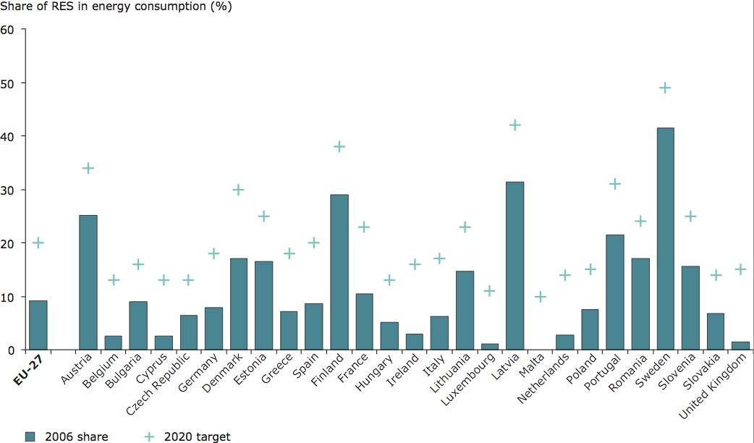
Figure 2: Share of RES in total energy consumption (in %)
(EEA, 2010)

Summary
This paper’s goal is to identify various energy relevant plans in Austria from the 1990s to 2005 and which strategies and aims these plans contain. In a further step, statistical data from 2005 till now was looked up, and the goals with the actual condition compared. The Kyoto Protocol was a major driver regarding energy policies in Austria. A „Kyoto Action-package“ was enacted, which laid out strategies for CO₂-eq. reduction for various sectors. A sustainability strategy should enhance energy efficiency while reducing the demand at the same time. Recent development (availability of resources, climate change etc.) led to the generation of an energy strategy.
Some of the goals set out in various strategies were reached, some not. Especially the share of renewables and hydrogen power on total electric power generation could be reached. The Kyoto goals on the other hand, and the CO₂-eq. reduction could not be reached. This implies, that strategies, reachable with the help of financial aids or rebates have more chance to success than taxes or regulations.

References
Anon. (2010). Eckpunkte der Energiestrategie Österreich. Bundesministerium für Wirtschaft, Familie und Jugend, Bundesministerium für Land- und Forstwirtschaft, Umwelt und Wasserwirtschaft, Wien. Available under: www.energiestrategie.at. Last checked: 22 April 2010.

BBC (2006a). Ukraine and Russia reach gas deal. Report of 4 January 2006. Available under: http://news.bbc.co.uk/2/hi/europe/4579648.stm. Last checked: 26 April 2010.

BBC (2006b). Ukraine gas row hits EU supplies. Report of 1 January 2006. Available under.: http://news.bbc.co.uk/2/hi/europe/4573572.stm. Last checked: 26 April 2010.

BBC (2008). Gazprom cuts Ukraine gas supply. Report of 3 March 2008. Available under: http://news.bbc.co.uk/2/hi/business/7274380.stm. Last checked: 26 April 2010.

BMLFUW (2002a). Molterer: Österreich soll Spitzenposition bei Biomasse-Nutzung ausbauen"Marktanteil" erneuerbarer Energieträger bis 2010 auf ein Drittel steigern. Avialable under: http://www.lebensministerium.at/article/articleview/23358/1/6662/. Last checked: 25 April 2010.

BMLFUW (2002b). Molterer: Weltweit verbindlicher Klimaschutz rückt immer näherRatifizierung des Kyoto-Protokolls durch Österreich und die anderen EU-Länder ist wichtiges Signal. Available under: http://www.lebensministerium.at/article/articleview/23462/1/6662/. Last checked: 26 April 2010.

BMLFUW (2002c). Österreichs Zukunft Nachhaltig Gestalten: Die Österreichische Strategie zur Nachhaltigen Entwicklung. Wien. Avialable under: http://www.lebensministerium.at/filemanager/download/6823/. Last checked: 20 April 2010.

BMLFUW (2002d). STRATEGIE ÖSTERREICHS ZUR ERREICHUNG DES KYOTO-ZIELS. Wien. Available under: http://www.lebensministerium.at/filemanager/download/6819/. Last checked: 20 April 2010.

BMWFI (2009). Energiestatus Österreich 2010. Wien. Available under: http://www.bmwfj.gv.at/EnergieUndBergbau/Energiebericht/Documents/Energiestatus%202010%20inkl.%20Vorwort.pdf. Last checked: 25 April 2010.

DerStandard (2005). Russland bleibt im Gas-Streit hart. Report of 31. Dezember 2005. Available under: http://derstandard.at/2291054. Last checked: 25 April 2010.

EEA (2009). European Environment Agency: Non-industrial emissions key for meeting Kyoto targets. Available under: http://www.eea.europa.eu/pressroom/newsreleases/non-industrial-emissions-key-for-meeting-kyoto-targets. Last checked: 24 April 2010.

EEA (2010). Share of RES in final energy consumption (%) in EU-27 in 2006 compared to 2020 targets. Available under: http://www.eea.europa.eu/data-and-maps/figures/share-of-res-in-final-energy-consumption-in-eu27-in-2006-compared-to-2020-targets. Last checked: 9 May 2010.

European Commission (1997), ENERGY FOR THE FUTURE: RENEWABLE SOURCES OF ENERGY, White Paper for a Community Strategy and Action Plan. Available under: http://europa.eu/documents/comm/white_papers/pdf/com97_599_en.pdf Last Checked: 8 May 2010.

FAZ (2009). Frankfurter Allgemeine Zeitung: Russland dreht den Gashahn zu. Report of 1 January 2009. Available under: http://www.faz.net/s/RubDDBDABB9457A437BAA85A49C26FB23A0/Doc~EFF36F61A00D242449CECF438410A6DFD~ATpl~Ecommon~Scontent.html. Last checked: 26 April 2010.

Neuwirth (2008). Environmental Controversy and Environmental Awareness in Austria – a Short Online Environmental History. Available under: http://www.nachhaltig.at/Environmental_History_V200803.pdf. Last checked: 24 April 2010.

Umweltbundesamt (2010). Environment Agency Austria: AUSTRIA'S ANNUAL GREENHOUSE GAS INVENTORY 1990–2008. Vienna. Available under: http://www.umweltbundesamt.at/fileadmin/site/publikationen/REP0187.pdf. Last Checked: 10 May 2010.

Veichtlbauer O. (2007). ETA: Environmental History Timeline Austria - Zeittafel zur Umweltgeschichte Österreichs seit 1945. Available under: www.iff.ac.at/umweltgeschichte/files/ETA.pdf. Last checked: 24 April 2010.

In this paper, the term „renewable resources“ refers mainly to biomass but also to solar and wind power. Hydrogen power is not included into this term.
Space heating, eclectricity and heat production, transportation, manufacturing and trade, waste management, agricutlure and floureszent gases.
27.9 % after substracting the exports.

